**INTRODUCTION TO**

**INTERNET BASICS**

**LAB # 06**



**Fall 2021**

**CSE102L Computer Programming Lab**

Submitted by: **Ali Asghar**

Registration No. : 21PWCSE2059

Class Section: **C**

“On my honor, as student of University of Engineering and Technology, I have neither given nor received unauthorized assistance on this academic work.”



Student Signature: ______________

Submitted to:

**Engr. Abdullah Hamid**

January 20, 2022

Department of Computer Systems Engineering

University of Engineering and Technology, Peshawar

**Q 1: Explain How you will access a Wi Fi router admin panel, attach screenshots of each step?**

**Ans:**

**STEP 1: FIND THE IP ADDRESS OF YOUR WIFI**

Identify the IP address of the router. Most routers are manufactured to use a default address such as 192.168.0.1, 192.168.1.1, 192.168.2.1, or 192.168.1.100. The IP address can also be found on the router. If those don't work, and you don't know the router's default IP address or it was changed, you need to find your default gateway IP address.

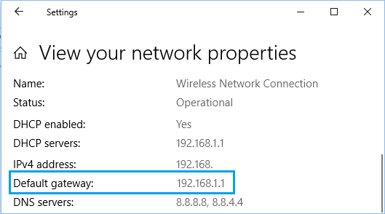

**STEP 2: ENTER THE IP ADDRESS IN THE WEB BROWSER**

In a web browser, such as Microsoft Edge, Internet Explorer, Chrome, or Firefox, request a connection to the router. Do this by typing the router's IP address (in the format **http://192.168.1.1**) in the browser's address bar.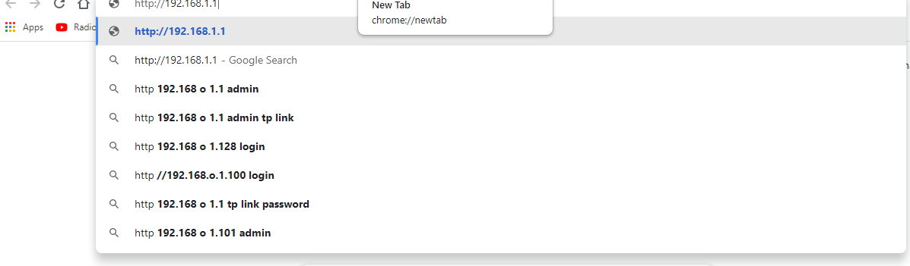

**STEP 3: ENTER THE LOGIN INFORMATION**

Enter the administrative login information—username and password—to authenticate and access the admin settings.

Routers are shipped with default usernames and passwords—usually, the word **admin**is the default username,but it could be different for your router. Some routers might not have a password or username.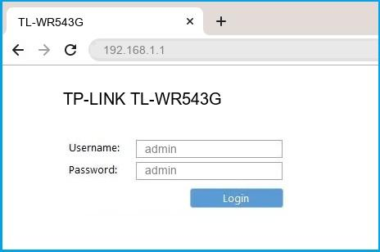

**Q 2: Explain How you will send an email with an attachment that has a size more than 30MB, explain each step and attach screenshot for each step in the lab report?**

**Ans:**

**1: GOOGLE DRIVE**

With Gmail, we can send attachments limited to 25MB and receive files of up to 50MB. It makes sense to use the built-in Google Drive to send big files. Open your Gmail account and click the **Compose** button. Click the **Google Drive** icon at the bottom of the compose window. 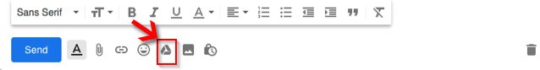

The Insert files using Google Drive window appears. Select the files you want to attach. At the bottom of the page, decide how you want to send the file:

Drive link works for any files stored in Drive, including files created using Google Docs, Sheets, Slides, or Forms.

Attachment only works for files that weren't built using Docs, Sheets, or Slides.

Then click Insert

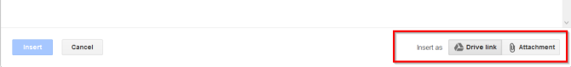

Gmail checks to see if your recipients have access to the file. If they don't, it'll prompt you to [change the sharing settings of your file stored in Drive](https://www.makeuseof.com/tag/google-drive-sign-file-sharing-made-easy/) before sending the message. You can set permissions to prevent the file from getting misused and send them to selected recipients.

Similarly, we can use:

[**OneDrive**](https://onedrive.com/): For Outlook and Outlook.com

[**Dropbox**](https://www.dropbox.com/): Integrate With Gmail

[**iCloud Mail Drop**](https://www.icloud.com/): Use With Apple Mail

**2: DIRECT BIG FILES TRANSFER METHOD(Using WeTransfer)**

[WeTransfer is a fantastic choice to send files online](https://www.makeuseof.com/what-is-wetransfer/). For free, and without an account, you can send files up to 2GB; there's no limit to how often you can use the service either. You can either send these files directly via email or generate a link which you can share elsewhere.

**What Is WeTransfer?**

WeTransfer is a cloud-based content-sharing platform ideal for sharing large files. File sharing is an essential service today. Emails are handy for smaller files, and cloud storage like Google or iCloud works well for sharing high-quality photos, documents, or videos. However, over time, these storage options run out of space and require constant clean-up.

**How to Share Files On WeTransfer:**

**STEP 1:**

Click the **plus** icon or drag and drop files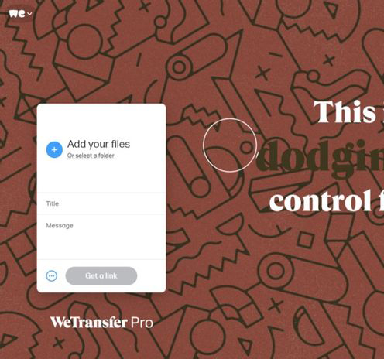

**STEP 2:**

Enter both the recipient's and your email address.

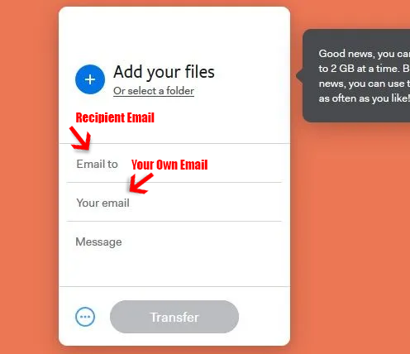

**STEP 3:**

Then, enter the title and body of the message you want to send.

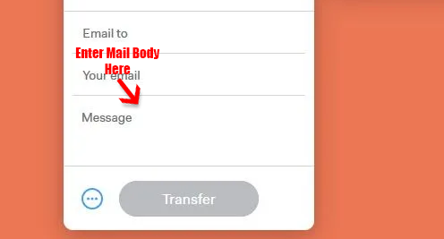

**STEP 4:**

Click the ellipsis and select the options to transfer the file. You can send the file via email or generate a transfer link that to share through any messenger.

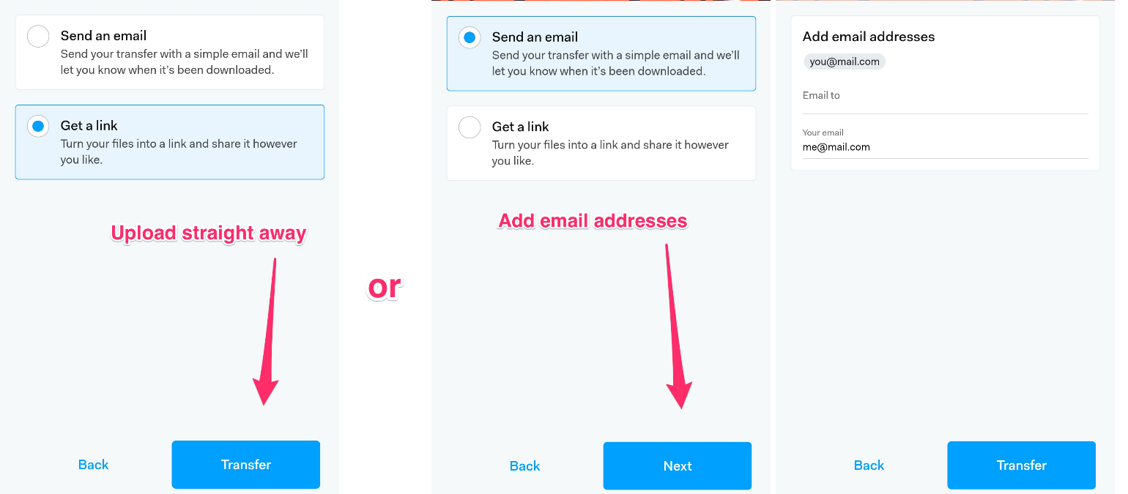

**HONOURABLE MENTIONS**

These also works the way as WeTransfer.

[**pCloud** Transfer](https://transfer.pcloud.com/): Simple Encrypted File Transfer

[**DropSend**](https://www.dropsend.com/): Send Large Files From Any Device

[**SendThisFile**](https://www.sendthisfile.com/): End-to-End Encrypted Transfers